**Facebook Sign-In Integration: Flutter**

**Android:**

* Used [flutter_login_facebook](https://pub.dev/packages/flutter_login_facebook) package
* To be able to sign-in via facebook, you first have to create facebook developer account in [facebook console](https://developers.facebook.com/)
* You need to: [Select an App or Create a New App](https://developers.facebook.com/docs/facebook-login/android?locale=en_US#1--select-an-app-or-create-a-new-app).
* After creating the app you need to add Platform (i.e. Android or Ios ) which will be your actual app.
  + For android you need to add your application package (i.e. com.example) & MainActivity name (i.e. com.example.MainActivity)
  + You also need to provide hash-key of your application, this hash key can be obtained by simple java/kotlin code, and for your reference I’ve added this at the end of this doc.
* Add values to /android/app/src/main/res/values/strings.xml (create file if it doesn't exist). You don't need to add fb_login_protocol_scheme, only facebook_app_id and facebook_client_token.
* How to get your Client Access Token:
  + Sign into your [developer account](https://developers.facebook.com/).
  + On the [Apps page](https://developers.facebook.com/apps/), select an app to open the dashboard for that app.
  + On the **Dashboard**, navigate to **Settings** > **Advanced** > **Security** > **Client token**.
* Make changes in android/app/src/main/AndroidManifest.xml:
  + Add a meta-data elements in section application:
  + 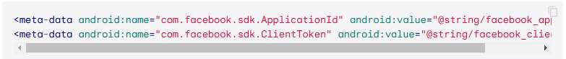
* To resolve “**Namespace not specified”** error while running the app, I’ve added following code above “allProjects” declaration inside root-level project.gradle file :

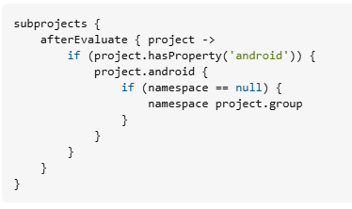

Get Hash Key Function In MainActivity :  
  
package com.example.flutter_social_sign_in_poc  
  
import android.content.pm.PackageInfo  
import android.content.pm.PackageManager  
import android.content.pm.Signature  
import android.os.Bundle  
import android.util.Base64  
import android.util.Log  
import io.flutter.embedding.android.FlutterActivity  
import java.security.MessageDigest  
import java.security.NoSuchAlgorithmException  
  
class MainActivity : FlutterActivity() {  
 override fun onCreate(savedInstanceState: Bundle?) {  
 super.onCreate(savedInstanceState)  
 getHashKey()  
 }  
  
 private fun getHashKey() {  
 try {  
 val info: PackageInfo = packageManager.getPackageInfo(  
 "com.example.flutter_social_sign_in_poc", // Replace with your app's package name  
 PackageManager.GET_SIGNATURES  
 )  
 for (signature: Signature in info.signatures) {  
 val md: MessageDigest = MessageDigest.getInstance("SHA")  
 md.update(signature.toByteArray())  
 val something = String(Base64.encode(md.digest(), Base64.DEFAULT))  
 Log.e("hash key", something)  
 }  
 } catch (e1: PackageManager.NameNotFoundException) {  
 Log.e("name not found", e1.toString())  
 } catch (e: NoSuchAlgorithmException) {  
 Log.e("no such algorithm", e.toString())  
 } catch (e: Exception) {  
 Log.e("exception", e.toString())  
 }  
 }  
}